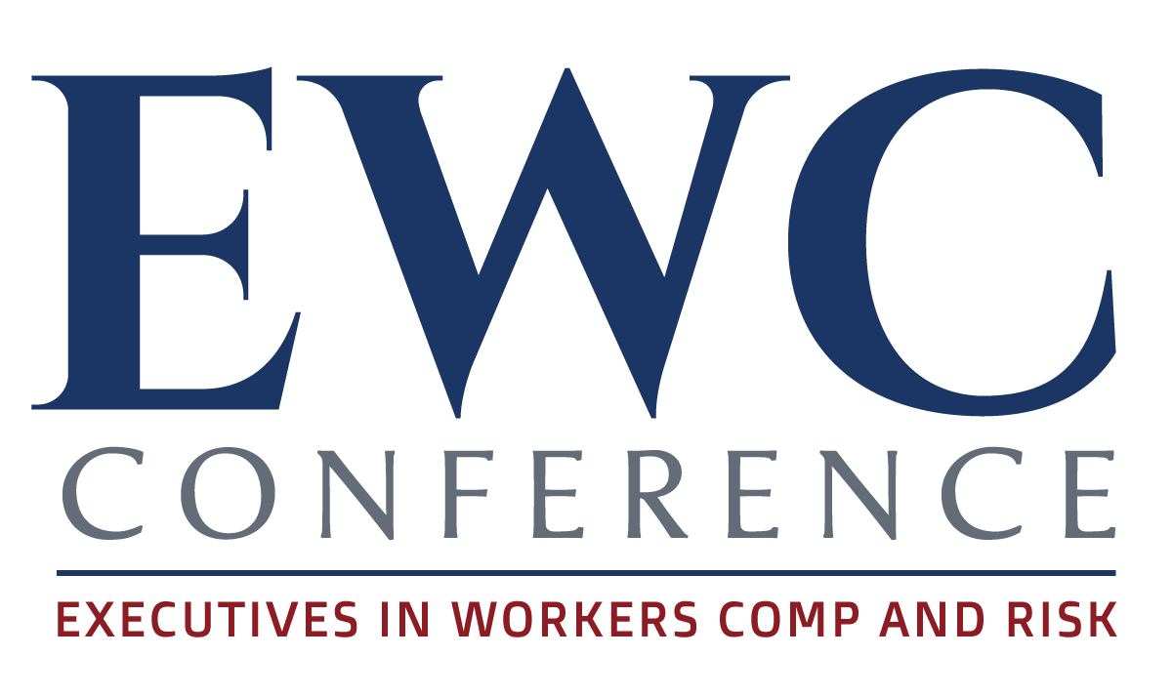
Please fill out and return to info@EWCevents.com

Submit by November 15, 2022

- Please submit an original session that has not been presented at any other conference, webinar or in-house training. We require original sessions that have not been presented before.
- If you are selected to speak, you cannot present this topic to any other conference, webinar or training until after the EWC Conference, April 25, 2023.
- We reserve the right to remove any speaker selected for presenting the same topic elsewhere.
- If you are a service provider, you must have a Risk Manager or Worker s’ Comp rofessional speak with you.
- You agree to send out information to your database to promote your session and the EWC conference.
Step 1: Speaker Identification Information

Step 1: Submitter Identification
As the submitter, please provide your contact information.
Step 2: Session Information
Provide session details as requested.
Step 3: Speaker Information
Please complete the entire form.

DO NOT HIGHLIGHT YOUR COMMENTS, TYPE IN BOLD OR ALL CAPS, OR SEND US YOUR INFORMATION IN A PDF FORMAT.

Speaker Name
Company
Work Phone
Cell Phone
Email
Website

List a second contact:
Name
Work Phone
Cell Phone
Email

Step 2: Session Information

You recommend you have a 3-person panel. The panel should include a Risk Manager and a Workers’ Comp professional. However, you may submit a single or double speakers.

Topics must to geared to upper and middle management.
Provide session details. Be as precise and descriptive as possible. The more direct you are, the easier it is for our content team to understand exactly what you plan to accomplish.

The information you provide will be published on the website. The attendees will determine which sessions to attend solely based on the information provided in this form. Therefore, you want your description to stand out and capture maximum interest.

Please complete the information below.
*Items with a red asterisk are required. The information provided will be published on our website and in the conference brochure so do not skip any of these questions.

*Title. Make sure the title is interesting. This is what attendees will read to determine if they want to attend your session.

*Description of the session.

*Why would upper and middle management be interested in hearing this topic?

*Outline your talking points. Think about communicating with upper management attendees and why they would want to spend time learning about your topic. Make sure you are providing new and fresh information.

*What challenges are you solving for upper and middle management attendees?

* List 3 or 4 takeaways from your session.

* What are the action items from your session?

*Please comment on the action item that upper management attendees will incorporate into their claims team management.

Step 3: Additional Speaker Information

Please list who you would partner with to provide a compelling presentation. You must have at least 3 persons on the panel. At least two must be Workers’ Comp or Risk Management Professionals.

*Please provide headshots of all speakers on your panel. Include their name, title and company.

Please provide your co-presenter(s) information below.

*Speaker #1
*Name
*Title
*Company
*Email
*Phone

*Speaker #2
*Name
*Title
*Company
*Email
*Phone

*Speaker #3
*Name
*Title
*Company
*Email
*Phone

*Speaker #4
*Name
*Title
*Company
*Email
*Phone

*Speaker #5
*Name
*Title
*Company
*Email
*Phone

*Speaker #6
*Name
*Title
*Company
*Email
*Phone

Step 4: Session Information Review

Review and edit all information you’re submitting.

Step 5: Session Submission Complete

It’s always a good idea to save your document as a backup copy.

Email submissions to info@EWCevents.com with the subject line Speaker Topic Form Attached.
Please note that we do not pay for speakers fees, rooms or travel. You may join us for break and lunch and snacks during the conference.

Thank you for your updated speaker information.
We greatly appreciate your time and thoughtfulness in putting your presentation together.

The EWC Speaker Selection Committee

